Michael Chizy, Chairman  John L. Hebert, Vice Chairman  Richard Hersom, Clerk  Ryan Fattman  Kevin Geraghty  James A. Smith, Town Administrator | 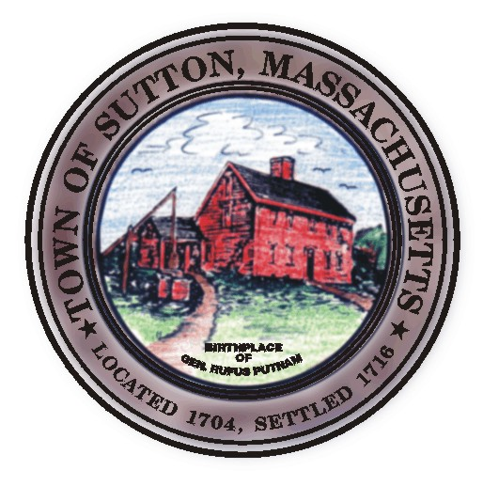 | Sutton Town Hall  4 Uxbridge Road  Sutton, Massachusetts 01590  (508) 865-8727  Fax: (508) 865-8721
Town Of Sutton
Board Of Selectmen

Meeting Agenda

7:00 p.m. – Tuesday, August 5, 2008

Sutton Town Hall, Selectmen’s Meeting Room

- Call to Order, Pledge of Allegiance at 7:00 p.m.

- Public Forum: Limited to 5 minutes per topic. Discussion or comments about town employees or agency members shall be avoided so as not to violate individual’s rights.

- Minutes
  - Board of Selectman minutes from 07/15/08

Proclamation in honor of Eagle Scout David John Surprenant

IV. Sponsored Agenda and Action Items

****** PUBLIC HEARING ******
Class I & II Dealers License :
2. D.R. Stone Inc. dba Car Custodian Ray Stone owner (previously owned by Jan Hanratty)
3. Appointment to Recreation Commission – Brian Allen
4.

V. Town Administrator Update
VI. Announcements
VII. Selectman’s Roundtable: Correspondence and Business Topics

Adjournment

